Tender document
Anchor point for rope access

Pos. XX.XXX : Anchor point for rope access
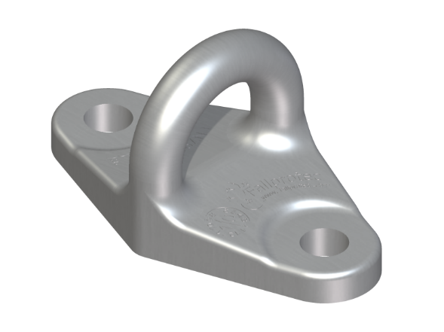
Anchor point for fall arrest and rope access applications. Certified as per EN795:2012 Type A and TS16415:2013 for the fall of two users simultaneously.
The anchor point is made of high-grade stainless steel AISI316. It must be undeformable at 6kN and have a minimum breaking strength of 15kN. The anchor point must comply with the design criteria of rope access guidelines such as IRATA or BS7985.
The anchor point has an opening of minimum 24mm to allow the connection of aluminium or steel carabiners complying to EN362.
The anchor point has two holes of ø12,5 mm to allow fixing to the structure. When used for rope access, the hoist structure must be rigid and withstand a minimum breaking strength of 15kN. It is either:
- Fixed on concrete slab.
Minimum quality 25mPa. Min. thickness of slab 125mm. Min. distance to edge of concrete 100mm.
Chemically fixed with two threaded bars quality A4, embedded min. 100mm in concrete.

- Fixed on steel beam with two fasteners M12, quality A4.

If the structure has a layer of isolation or cladding, special galvanized steel or stainless-steel posts with min. breaking strength 15kN, must be supplied.
The anchor points are installed in a way that the rope access technicians can reach every part of the facade.
The distance between anchor points are either:
- 2 anchor points installed every 2000mm

- 1 anchor point installed every 1000mm, especially when installed on ceiling and rope access technician, must make a transition from one to another while being suspended.
The offer includes the layout drawings, the supply and installation of the material and the commissioning by a specialized inspection company or a competent person authorized by the manufacturer.

Brand: Fallprotec
Type: Twinfix
Quantity:

